Chapter 18, Problem 44.

If the rectangular pulse in Fig. 18.46(a) is applied to the circuit in Fig. 18.46(b), find v_{o} at t = 1 s.

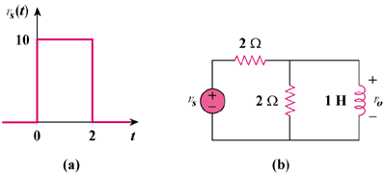

Figure 18.46
For Prob. 18.44.

